Amendments and Alignment of Part II (Requirements for the Management of Schemes) Criteria Across SSCI Scopes
Public Stakeholder Consultation

September 2022

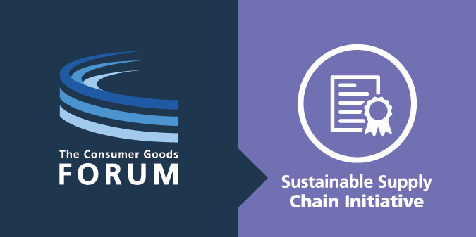
Foreword

I am very pleased to write to you today as the Sustainable Supply Chain Initiative (SSCI) reaches yet another important milestone. In recent months, the SSCI has gained significant momentum, supported by the CEOs of our member companies who publicly emphasised the value of SSCI for their businesses and called on sustainability schemes to apply for SSCI Recognition. A growing number of schemes are now participating in the SSCI Benchmark process, and we are reviving work to extend the scope of the SSCI to environmental sustainability schemes.
As the SSCI grows, we identify and capture learnings and improvement opportunities to continue building a robust and trustworthy recognition model and to serve our purpose of supporting organisations in their supply chain due diligence. Once again, based on such learnings, the SSCI steering committee is preparing to make decisions affecting the SSCI Benchmarking Requirements; to support their decision-making process, they wish to gather stakeholder feedback on the opportunities they identified.
Consulting with our many stakeholders is critical to SSCI: it guarantees input from the widest possible range of experts, and transparently provide insight into the direction the SSCI is taking. I would like to thank our stakeholders for continuing to actively take part in our public consultations and support our work by doing so; as the SSCI is growing, your feedback and suggestions make the SSCI recognition model stronger and more trustworthy.

Signed,
Didier Bergeret
Director, Sustainability
The Consumer Goods Forum

Purpose of this consultation

The SSCI Benchmark helps build trust in sustainability standards worldwide by recognising third-party sustainability certification, monitoring, and audit schemes that meet industry-defined expectations for sustainability. Those expectations are expressed in the SSCI Benchmarking Requirements, which schemes must satisfy if they want to become and remain recognised.
Part II of the SSCI Benchmarking Requirements (“Requirements for the Management of Schemes”, or “Scheme Management Criteria”) defines the governance requirements for sustainability schemes. These criteria were first developed for the SSCI’s Manufacturing and Processing scope, and have been adapted for the SSCI’s Primary Production and At-Sea Operations scopes.
Overall, an analysis of the content included in the Scheme Management Requirements across all three scopes demonstrates: 58% of all key elements in the Scheme Management Criteria are common across all benchmarking scopes
- 36% of elements are specific for the Primary Production sector, addressing small holders and multisite / group certification
- 6% of elements differ between scopes in varying degrees, from editorial differences with no impact on intent, to expressions of different intents.
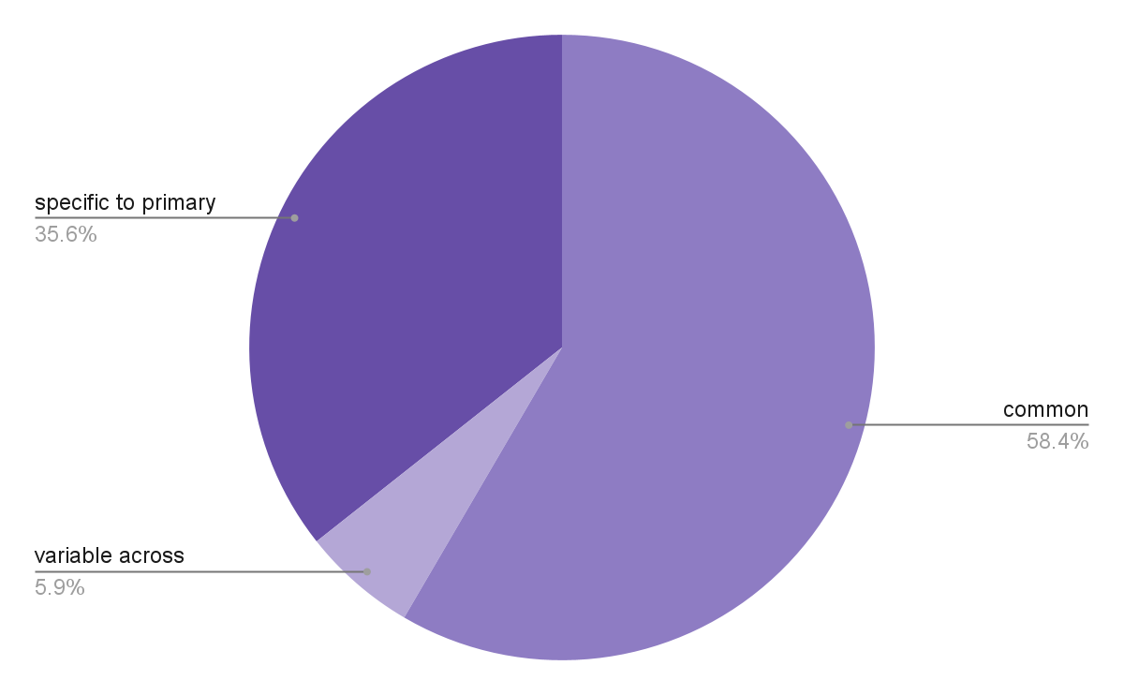
Different requirements between scopes bring challenges during the benchmark process for schemes that have applied for SSCI Recognition under more than one scope. They also create an uneven playing field between SSCI-recognised schemes, which is not always justified by the specificity of the industry sectors addressed by those schemes.
In July 2022, the SSCI Steering Committee decided to explore creating a single set of Scheme Management Requirements for all SSCI scopes. Subsequently, a series of amendments to the current set of requirements was identified to achieve this vision. These amendments are presented in the table 1 below.
Additionally, the SSCI Steering Committee also decided to reconsider the following requirement which sets an expectation regarding the ownership of schemes:
A1.02: The scheme cannot be managed or owned in whole or in part by an audit firm or group of audit firms to ensure that the scheme owner is not directly engaged in operational affairs (auditing or certification) of the programme.
The SSCI recognises the ownership of schemes by auditing companies is relatively common in our industry. More importantly, such schemes sometimes developed robust impartiality processes between their auditing and scheme management activities, thus achieving the underlying intent of the SSCI requirement. In light of this, the SSCI Steering Committee is considering amending the requirement A1.02 as illustrated in table 2.
The purpose of this consultation is to submit those proposed changes to the scrutiny of the SSCI stakeholder community and support the SSCI Steering Committee with its final decision regarding:
- The creation of a single and harmonised set of Scheme Management Criteria (Part II of the SSCI Benchmarking Requirements) for all SSCI scopes
- The modification of SSCI requirements regarding the ownership of schemes by auditing firms
How to respond to this consultation

You may respond to this consultation by completing the form in appendix 1 of this document and email it to ssci@theconsumergoodsforum.com.
To ensure your comments and suggestions are considered, please ensure to send us your response before the 5th October 2022

Table 1: Proposed Amendments to Part II Requirements for Cross-scope Harmonisation

ref | scope | current text | proposed text (proposed changes in bold)
A2.02 | Primary Production | If the Scheme's auditing scope includes smallholders/family farms, the Scheme owner shall have clear rules for the classification of producers as "smallholder/family farm" producers. | For schemes addressing the primary production sector, if the Scheme's auditing scope includes smallholders/family farms, the Scheme owner shall have clear rules for the classification of producers as "smallholder/family farm" producers.
C1.01 | Primary Production | The Scheme Owner shall indicate whether or not it provides any specific requirements, exemptions, rules and definitions for smallholders in its assessment process | For schemes addressing the primary production sector, the Scheme Owner shall indicate whether or not it provides any specific requirements, exemptions, rules and definitions for smallholders in its assessment process
C1.02 | Primary Production | The Scheme Owner shall indicate in the audit or assessment report whether smallholders were covered during any particular assessments or certification process | For schemes addressing the primary production sector, the Scheme Owner shall indicate in the audit or assessment report whether smallholders were covered during any particular assessments or certification process
C1.03 | Primary Production | The Scheme Owner shall disclose their complete list of exemptions for smallholders | For schemes addressing the primary production sector, the Scheme Owner shall disclose their complete list of exemptions for smallholders
B3.02 | Primary Production | The lead auditor performing audits for the audit firm shall have the following experience:  - a minimum of 1-year experience in social compliance auditing and a minimum of 100 social compliance audit days  or  - a minimum of 2 years experience in any other type of auditing and 150 audit days of which a minimum of 50 are social compliance audit days. Other audit days may include management system, health and safety, labor inspections, investigations, audit components.  or  - a detailed combination of minimum relevant experience in social compliance, trainings, and social compliance audit days that are publicly available and consistent with standard industry practices & norms | The lead auditor performing audits for the audit firm shall have the following experience:  - a minimum of 1-year experience in social compliance auditing and a minimum of 100 social compliance audit days  or  - a minimum of 2 years experience in any other type of auditing and 150 audit days of which a minimum of 50 are social compliance audit days. Other audit days may include management system, health and safety, labour inspections, investigations, audit components  or  - a detailed combination of minimum relevant experience of 3 years in social compliance training, and social compliance audit days, a minimum of which 50 are social compliance audit days, that are publicly available and consistent with standard industry practices and norms.
 | At-Sea Operation | The lead auditor performing audits for the audit firm shall have the following experience:  - a minimum of 1-year experience in social compliance auditing and a minimum of 100 social compliance audit days  or  - a minimum of 2 years experience in any other type of auditing and 150 audit days of which a minimum of 50 are social compliance audit days. Other audit days may include management system, health and safety, labor inspections, investigations, audit components.  or  - a detailed combination of minimum relevant experience in social compliance, trainings, and social compliance audit days that are publicly available and consistent with standard industry practices & norms
 | Manufacturing and Processing | The lead auditor performing audits for the audit firm shall have the following experience:  - a minimum of 1-year experience in social compliance auditing and a minimum of 100 social compliance audit days  or  - a minimum of 2 years experience in any other type of auditing and 150 audit days of which a minimum of 50 are social compliance audit days. Other audit days may include management system, health and safety, labor inspections, investigations, audit components  or  - a detailed combination of minimum relevant experience of 3 years in social compliance training, and social compliance audit days, a minimum of which 50 are social compliance audit days, that are publicly available and consistent with standard industry practices and norms.
B4.06 | Primary Production | The audit shall take place during a period when the employment site is in normal operation. Resulting variations to audit frequency shall be clearly defined and documented. | The audit shall take place during a period  - for at sea operation: when on-site observation can take place, evidence can be collected, and interviews can occur.  - for all other scopes: when the employment site is in formal operation.  Resulting variations to audit frequency shall be clearly defined and documented.
 | Manufacturing & Processing | The audit shall take place during a period when the employment site is in normal operation. Resulting variations to audit frequency shall be clearly defined and documented.
 | At-Sea Operations | The audit shall take place during a period when on-site observation can take place, evidence can be collected and interviews can occur. Resulting variations to audit frequency shall be clearly defined and documented.
B4.08 | Primary Production | The Scheme Owner shall have in place auditing procedures and guidance for group/multi-site auditing and requires audit firms to apply the methodology consistently, if allowed under the scheme. | The Scheme Owner shall have in place auditing procedures and guidance for group/multi-site auditing and requires audit firms to apply the methodology consistently, if allowed under the scheme.
 | At-Sea Operations | The Scheme Owner shall have in place auditing procedures and guidance for multi-site auditing and requires audit firms to apply the methodology consistently, if allowed under the scheme.
 | Manufacturing & Processing | The Scheme Owner shall have in place auditing procedures and guidance for multi-site auditing and requires audit firms to apply the methodology consistently, if allowed under the scheme.
B4.07 | Primary Production | The Scheme Owner shall clearly define the expected duration of audits and the rationale for the determination of the duration of the audit that audit firms are required to follow during the audit. The rationale shall at a minimum include the size of the workforce and should include additional criteria that will ensure the effectiveness of the audit such as the physical size of the location to audit, number of locations, nationalities of the workforce, product lines and product categories, etc. | The Scheme Owner shall clearly define the expected duration of audits and the rationale for the determination of the duration of the audit that audit firms are required to follow during the audit. The rationale shall at a minimum include the size of the workforce and should include additional criteria that will ensure the effectiveness of the audit such as the physical size of the location to audit, number of locations, nationalities of the workforce, product lines and product categories, etc.
 | Primary Production | The Scheme Owner shall clearly define the expected duration of audits and the rationale for the determination of the duration of the audit that audit firms are required to follow during the audit. The rationale shall at a minimum include the size of the workforce and should include additional criteria that will ensure the effectiveness of the audit such as the physical size of the location to audit, number of locations, nationalities of the workforce, product lines and product categories, etc.
 | At-Sea Operations | N/A [element not present]
B4.10 | Primary Production | The Scheme Owner shall define requirements for the appointment of translators that audit firms are required to implement and make available.  In all cases where translators are used, the Scheme Owner shall guarantee their independence and confidentiality. | The Scheme Owner shall define requirements for the appointment of translators that audit firms are required to implement and make available.  In all cases where translators are used, the Scheme Owner shall guarantee their independence and confidentiality.
 | Manufacturing & Processing and At-Sea Operations | N/A [element not present]
B4.11 | At-Sea Operations | The Scheme Owner shall require audit firms to have policies and procedures in place to ensure the safety, protection and security of their auditors. | The Scheme Owner shall require audit firms to have policies and procedures in place to ensure the safety, protection and security of their auditors.
 | Manufacturing & Processing and Primary Production | N/A [element not present]
B1.01 | All scopes | The Scheme Owner shall require that audit firms achieve and maintain accreditation against the current version of ISO/IEC 17021-1 or ISO/IEC 17065 for the scope of the respective standard of the scheme. | “If the scheme is written to issue certificates of compliance, the Scheme Owner shall require that audit firms achieve and maintain accreditation against the current version of ISO/IEC 17021-1 or ISO/IEC 17065 for the scope of the respective standard of the scheme. Requirements B1.02 to B1.09 apply to the scheme.  If the scheme does not enable the issuing of certificates of compliance, the scheme must include:  (a) a designated person/persons in charge of the programme and a defined procedure and requirements for auditor selection, training and qualification;  (b) procedures for sampling methodology, audit days calculation and multisite audits  (c) any additional objective measures to ensure that the audit firm is able to conduct audits in accordance with the policies and procedures established by the scheme owner.  Requirements B1.02 to B1.09 do not apply to the scheme.”
B1.02 | Primary Production | In the event that an audit firm is not yet accredited to ISO/IEC 17021 or ISO/IEC 17065, the Scheme Owner may put procedures in place for a clearly defined transition period to allow audit firms to achieve ISO accreditation. If a transition period is granted, it shall not exceed two years. | In the event that an audit firm is not yet accredited to ISO/IEC 17021 or ISO/IEC 17065, the Scheme Owner may put procedures in place for a clearly defined transition period to allow audit firms to achieve ISO accreditation. If a transition period is granted, it shall not exceed two years.
 | At-Sea Operations | In the event that an audit firm is not yet accredited to ISO/IEC 17021 or ISO/IEC 17065, the Scheme Owner may put procedures in place for a clearly defined transition period to allow audit firms to achieve ISO accreditation. If a transition period is granted, it shall not exceed two years.
 | Manufacturing & Processing | In the event that an audit firm is not yet accredited to ISO/IEC 17021 or ISO/IEC 17065, the Scheme Owner may put procedures in place for a clearly defined transition period to allow audit firms to achieve ISO accreditation. If a transition period is granted, it shall not exceed two years.  The audit quality programme must include:  (a) a designated person/persons in charge of the programme and a defined procedure a requirement for auditor selection, training and qualification;  (b) procedures for sampling methodology, audit days calculation and multisite audits  (c) any additional objective measures to ensure that the audit firm is able to conduct audits in accordance with the policies and procedures established by the scheme owner.

Table 2: Propose Amendments to SSCI Requirement on Scheme Ownership

ref | scope | current text | proposed text
A1.02 | All scopes | The scheme cannot be managed or owned in whole or in part by an audit firm or group of audit firms to ensure that the scheme owner is not directly engaged in operational affairs (auditing or certification) of the programme | OPTION 1:  if the scheme is managed in part or in whole by an audit firm or a group of audit firms, the scheme owner shall require that the audit firm(s) are accredited, and only allowed accredited audit firms to operate their schemes, to ensure impartiality between the scheme management and auditing activities.  OPTION 2:  if the scheme is managed in part or in whole by an audit firm or a group of audit firms, the scheme owner shall require that the audit firm(s) are accredited, and only allowed accredited audit firms to operate their schemes, to ensure impartiality between the scheme management and auditing activities.  The Scheme Owner shall put procedures in place for a clearly defined transition period and plan to achieve full independence from certification or auditing activities. If a transition period is granted, it shall not exceed two years

Appendix 1: response to the stakeholder consultation

Consultation: Amendments and Alignment of Part II across SSCI scopes
Date of the consultation: September 2022
Name of respondent: Click or tap here to enter text.
Organisation represented by respondent: Click or tap here to enter text.
Question 1: would you recommend that part II of the SSCI Benchmarking Requirements be common to all SSCI scopes of recognition, allowing when relevant for scope specific differences, such as for auditor sector specific knowledge?
☐ YES
☐ NO
Question 2: why?
Click or tap here to enter text.

Question 3: if you have any editorial recommendations to make to the proposed changes laid in table 1 of the consultation document, please indicate them in the below table with a short explanation of your reason(s) for suggesting them.
ref | Original proposal | Your amended proposal | Comment / explanation
Click or tap here to enter text. | Click or tap here to enter text. | Click or tap here to enter text. | Click or tap here to enter text.
Click or tap here to enter text. | Click or tap here to enter text. | Click or tap here to enter text. | Click or tap here to enter text.
Click or tap here to enter text. | Click or tap here to enter text. | Click or tap here to enter text. | Click or tap here to enter text.
Click or tap here to enter text. | Click or tap here to enter text. | Click or tap here to enter text. | Click or tap here to enter text.
Click or tap here to enter text. | Click or tap here to enter text. | Click or tap here to enter text. | Click or tap here to enter text.
Click or tap here to enter text. | Click or tap here to enter text. | Click or tap here to enter text. | Click or tap here to enter text.
Click or tap here to enter text. | Click or tap here to enter text. | Click or tap here to enter text. | Click or tap here to enter text.

Question 4: would you recommend that the SSCI Requirement on the ownership of the scheme be changed to focus on impartiality from auditing and certification activities through accreditation, rather than prohibiting the ownership of the scheme by auditing firms?
☐ YES – the SSCI should allow schemes to be owned by auditing firms as long as the auditing firms operating and those owning the scheme are accredited
☐ NO – the SSCI requirement should not change; the schemes should not be owned by auditing firms
Question 5: why?
Click or tap here to enter text.

Question 6: if you answered yes to question 4, would you recommend that a transition plan towards full independence of the scheme from any auditing or certification companies be required?
☐ YES – the scheme may be owned by auditing firms when achieving SSCI recognition, but must have a plan not to be within 2 years of recognition (option 1 of table 2)
☐ NO – the scheme may be owned by auditing firms and remain so (option 2 of table 2)
Question 7: why?
Click or tap here to enter text.

Question 8: if you have any editorial recommendations to make to the proposed changes laid in table 2 of the consultation document, please indicate them in the below table with a short explanation of your reason(s) for suggesting them.
Original proposal | Your amended proposal | Comment / explanation
Click or tap here to enter text. | Click or tap here to enter text. | Click or tap here to enter text.
Click or tap here to enter text. | Click or tap here to enter text. | Click or tap here to enter text.
Click or tap here to enter text. | Click or tap here to enter text. | Click or tap here to enter text.
Click or tap here to enter text. | Click or tap here to enter text. | Click or tap here to enter text.

